**CHAPTER 1**

**TRAINING SCHEDULE**

|  |  |  |  |
| --- | --- | --- | --- |
| **S. no.** | **Date** | **Day** | **Topic** |
| 1. | 5/6/17 | Mon | Basics and Core Components |
| 2. | 6/6/17 | Tues | Features and History |
| 3. | 7/6/17 | Wed | JVM Architecture and Byte-Code |
| 4. | 8/6/17 | Thurs | A little bit of Code and Class files |
| 5. | 9/6/17 | Fri | Data Types Operators |
| 6. | 12/6/17 | Mon | OOPS and OOPS in java |
| 7. | 14/6/17 | Wed | Classes and Objects |
| 8. | 16/6/17 | Fri | Methods and Constructors |
| 9. | 19/6/17 | Mon | Packages and Interfaces |
| 10. | 20/6/17 | Tues | Exception Handling |
| 11. | 21/6/17 | Wed | Threads and Multithreading |
| 12. | 23/6/17 | Fri | ‘Java.lang’-Java’slanguage Fundamentals |
| 13. | 26/6/17 | Mon | Java.io’-Java’s I/O Mechanism |
| 14. | 27/6/17 | Tues | Java Connectivity |
| 15. | 29/6/17 | Thurs | J2EE |
| 16. | 30/6/17 | Fri | HTML and HTML5 |
| 17. | 3/7/17 | Mon | CSS |
| 18. | 3/7/17 | Mon | Boot strap |
| 19. | 4/7/17 | Tues | JSP |
| 20. | 5/7/17 | Wed | Java script |
| 21. | 6/7/17 | Thurs | JQuery |
| 22. | 10/7/17 | Mon | IBM BlueMix |
| 23. | 12/7/17 | Wed | Cloud Deployment |

**CHAPTER 2**

**INTRODUCTION**

“LaVida Cafe is a web application. This system is developed to automate day to day activity of a restaurant. Restaurant is a kind of business that serves people all over world with ready made food. This system is developed to provide service facility to restaurant and also to the customer. This restaurant management system can be used by employees in a restaurant to handle the clients, their orders and can help them easily find free tables or place orders. The services that are provided is food ordering and reservation table management by the customer through the system online, customer information management and waiter information management, menu information management and report. The restaurant menu is organized by categories (appetizers, soups, salads, entrees, sides and drinks) of menu items. Main objective build the system this is to provide ordering and reservation service by online to the customer. Each menu item has a name, price and associated recipe. A recipe for a menu item has a chef, preparation instruction sand associated ingredients. With this system online, ordering and reservation management will become easier and systematic to replace traditional system where are still using paper. To resister a meal online, the customer has to become a member first then he can access the later part of the site. this project to facilitate customer for make online ordering and reservation. The option of becoming member was only an attempt to avoid (to some extent) placing the fake bookings.

LaVida Cafe system is the system for manage the restaurant business. After successful login the customer can access the menu page with the items listed according to the special menu. The main point of developing this system is to help restaurant administrator manage the restaurant business and help customer for online ordering and reserve table. In proposed system user can search for a menu according to his choice i.e. according to price range and category of food and later he can order a meal.

The project is developing because; many restaurants have a lot difficult to manage the business such as customer ordering and reservation table. If the customer book an order and later wants to cancel the order, he is permitted to do this only within a specific time period. By using manual customer ordering is difficult to waiter keep the correct customer information and maybe loss the customer information. The customer is also given with the facility to view the status of the order and if the order is ready then he can go and get it.

So, LaVida Cafe will develop to help the restaurant administrator to manage restaurant management and for customer make their online ordering and reservation table. At Management side, initially the staff member has to login, and according to his designation the privileges are set. Other than that, this project is to upgrade the manual system and make the business easily to access and systematic. If the staff member is a cook, then he is allowed to edit only the order items status, indicating which menu items he has prepared.

**ABBREVIATIONS**

* JS : Java Script
* JSP : Java Server Page
* CSS : Cascading Styling Sheet
* HTML : Hyper Text Markup Language

**CHAPTER 3**

**SOFTWARE DEVELOPMENT METHODOLOGY**

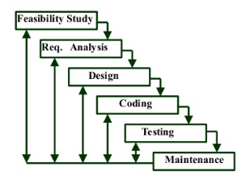

**FIGURE 1**

WATERFALL ITERATIVE MODEL contains 6 phases:

o Feasibility study: The feasibility study activity involves the analysis of the problem and collection of the relevant information relating to the product. The main aim of the feasibility study is to determine whether it would be financially and technically feasible to develop the product.

o Requirement analysis and specification: The goal of this phase is to understand the exact requirements of the customer and to document them properly (SRS)

o Design: The goal of this phase is to transform the requirement specification into a structure that is suitable for implementation in some programming language.

o Implementation and unit testing: During this phase the design is implemented. Initially small modules are tested in isolation from rest of the software product. Integration and system testing: In this all the modules are integrated and then tested altogether.

o Operation and maintenance: Release of software inaugurates the operation and life cycle phase of the operation.

**CHAPTER 4**

**SYSTEM REQUIREMENT SPECIFICATION**

* + - **Hardware:**

|  |  |
| --- | --- |
| PROCESSOR | **Intel Core i3** |
| RAM | 4GB |
| HARD DISK | **500 GB** |
| **MONITOR** | **LCD Monitor** |
| KEYBOARD | **101 Keys and more** |
| **MOUSE** | **Simple Mouse** |

* + - **Software:**

|  |  |
| --- | --- |
| PLATFORM | Eclipse Mars |
| OPERATING SYSTEM | WINDOW 10 |
| LANGUAGES | HTML,JAVA,JS,CSS |
| SERVER PAGE | JSP |
| BROWSER | Google Chome |

**CHAPTER 5**

**OBJECTIVE**

The main objective of this project is to develop a client/server model, which deals with all kind of services present in restaurant. The system has two parts first for the customers and the other for the management side.

The customer side allows the customer to view menu list and reserve meal with special time and can add extra services if need for special occasion and at the management side the staff is allowed to edit information regarding menu list, price, assigning cook, maintain information regarding the orders placed, etc. This system is transparent about the services it provides and easy to use. For business owners it saves time, business resources and expenses.

**CHAPTER 6**

**SCOPE**  
  
This webpage is developed to help computer science students to learn about the Web application designing using JSP and HTML from their basic capabilities to build a complete working application from 5 scratch. Further, it gives insight about how GUI interacts with server-side language, Java, and finally with the DB2 database.

**CHAPTER 7**

**SECURITY**

Security is an important aspect of the mobile application; as the restaurant management would want the application to be operational only in the premises, also mentioned in the requirements section R10. In case the application is available outside the boundaries of the restaurant, the clients can order food/drinks without being physically present in the restaurant. Therefore, the verification of the customer to be physically present before using the menu management system becomes important to stop any foul use.

**AVAILIBILITY**

If the system is deployed and used as an alternative to the manual system of order management, the entire restaurant business will be dependent on the menu management system. Therefore, to consider maximum availability will be an important parameter to consider while designing the architecture of the automated solution. Fault tolerance has to be considered in the system design so that the system is operational and running without much downtime. Service maintenance with respect to system uptime should be provided in an event of a failure to ensure availability.

**ADAPTIBILITY**

As the customers are not bound with a particular device or operating system to use the mobile application, adaptability becomes an important requirement. The design should work on multiple smartphone devices such as iOS, Android, Windows or Symbian with different screen sizes and resolution. Therefore, the adaptability of the application on multiple devices is a key criterion for design and testing in the implementation phase as also captured in R2 from the user survey results.

**USABILITY**

According to the key objectives outlined in previous chapters, the customers cannot be trained on the mobile application usage. The customer’s view has to be designed in a way that it is intuitive to use and is self‐explanatory across multiple devices. At the same time, the design should be simple and fast as the key measure of success is to reduce the order processing time. A complicated system with many screens or many scrolls up and down would defeat the purpose of the menu management system. The application design should thus comply with the three usability principles of early focus on users and tasks, empirical measurements, and iterative design.

**CHAPTER 8**

**OVERVIEW**

* **Customer**  
  This user will register to be a member to use the online system of this online restaurant management system. This online ordering divided into two type of customer; it is customer dine-in ordering and takeaway ordering. For dine in ordering, customer will view menu, make online ordering and make a reservation table. This system allows customer to place an order or allow him to cancel the book order.  But takeaway ordering, customer can view menu and online ordering without reservation table. During login, the costumer has to enter the time of delivery, and the menu items will appear accordingly. As availability of items differ from time to time. After customer make online ordering, customer can take ordering the date that customer was choose during make online ordering. Customers can search menu according to price range and the category as well, Event though, customer must confirm online ordering with restaurant three days before customer take the ordering for dine-in customer and for take-away customer will be confirm one hour before it whether by email or phone. customer can create his new account or he can edit his personal information from the existing account.
* **Administrator**

Administrator or manager is the person who will manage the entire system. he is allowed to reassign the cook according to his priority, he can edit the menu information such as its price, items available currently, etc. This type of user will also do maintenance and control the application of this system. A manager can reassign the cook for a specific order or an item. Administrator takes a responsibility to register new customer, register new waiter, register new menu into database. A manager can edit/create some or whole part of the menu record on daily basis. That is by changing the menu items, prices, description, etc.

**CHAPTER 9**

**OVERALL DESCRIPTION**

**Module of LaVida Café**

* **Customer Registration Module**

Customer registration module contains customer's information such as customer personal information and other information related to that customer. Then, all of this information recorded into database. Customers are given with a facility to change his existing password.

* **Customer Online Ordering And Reservation Module**

Customer online ordering and reservation module provides a form that needs to be fulfilling in term of ordering food and reservation table via online.

* **Waiter Module**

Waiter module contains waiter information such as waiter personal information, task schedule and other information related to that waiter. Then, all of this information recorded into database.

* **Feedback Module**

Based on food or everything about the restaurant, customer can send any suggestion or comment to the restaurant with feedback form. From this form, side of restaurant will know their weaknesses and strengths.

* **Menu Module**

Menu module is food that restaurant prepared for customer. This module, customer can view the menu and make decision for order.

* **Generate Report Module**

System provides an option for generate a report. The contents of the report as the following:

* 1. The report of customer ordering and reservation table.
  2. Customer's information and waiter information.
  3. Suggestion or comment that customer insert at feedback form
  4. Profit business for restaurant

This system will be going to help customer and administrator in restaurant especially part of online ordering and reservation table. Most of restaurant has a problem of the ordering and reservation table. A manager can create a new entry of cook or edit the existing cook’s information from the cook’s list. The result of online ordering and reservation table will give customer easy to make ordering and reservation table online and hopefully can smoother up the job of administrator and waiter. A manager can block a particular customer before signing up. This happens when the customer’s previous history is bad, This system also produces a computerized system in defining the best solution in each ordering and reservation problem faces by customer and administrator.  
The project with user and admin accounts, graphical room booking, booking amount calculation and appropriate billing. The System helps the restaurant manager to manage the restaurant more effectively and efficiently by computerizing meal ordering, and billing.

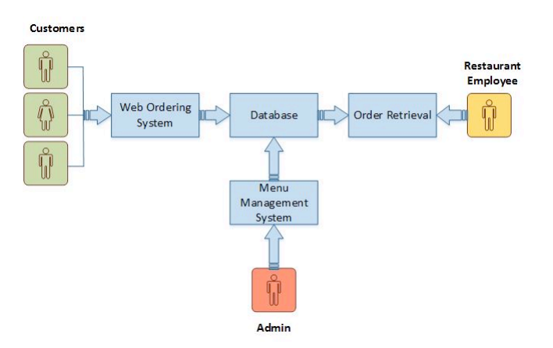

**FIRURE 2**

**CHAPTER 10**

**FUNCTIONALITY REQURIMENT SPECIFICATIONS DIAGRAM**

**System Flow Diagram**

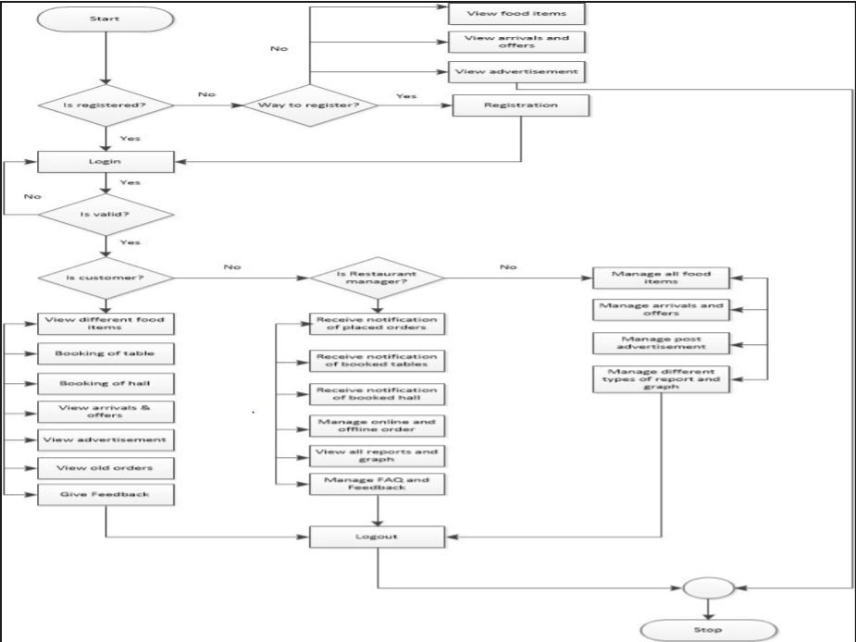

**FIGURE 3**

User Case Diagram

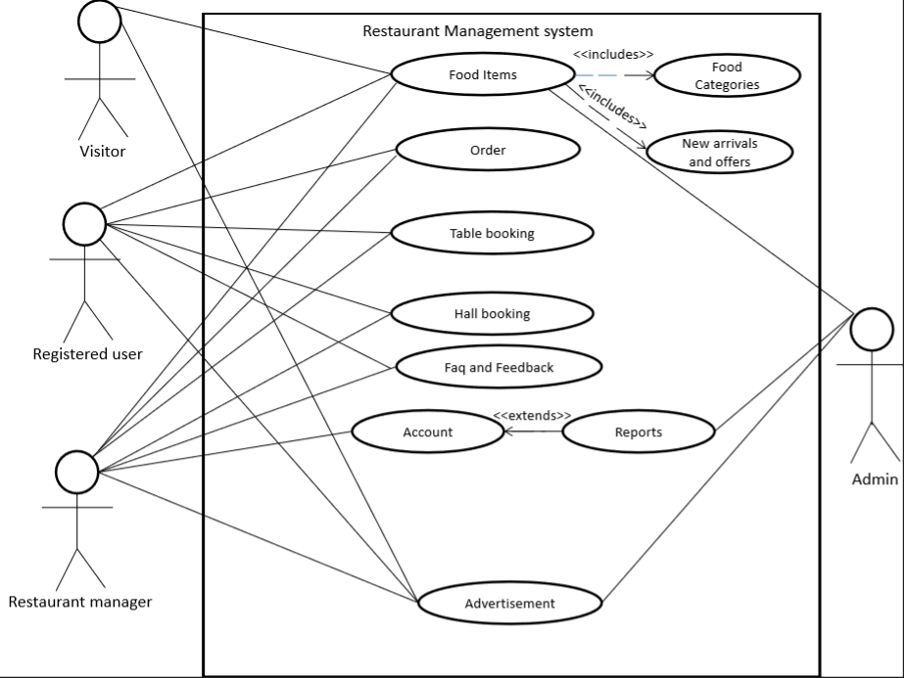

**FIGURE 4**

Activity Diagram

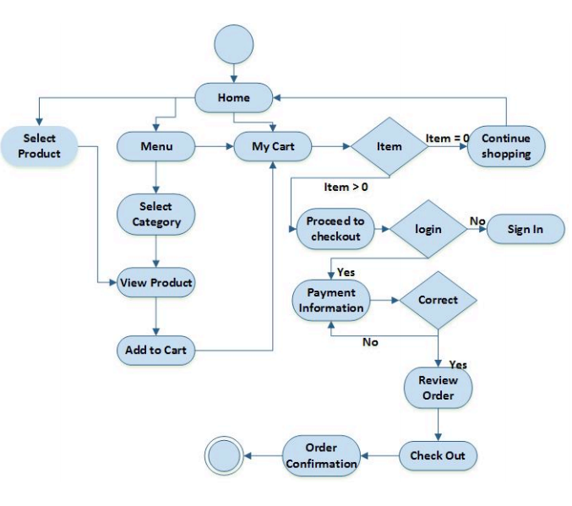

**FIGURE 5**

Class Diagram

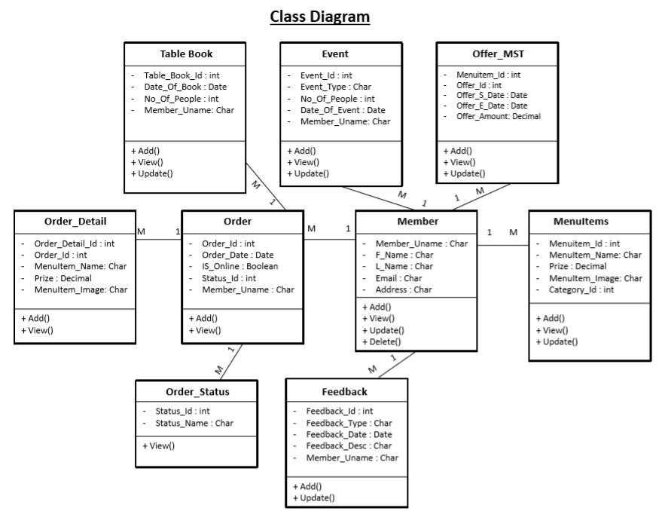

**FIGURE 6**

**CHAPTER 11**

**DATA FLOW DIAGRAM (DFD)**

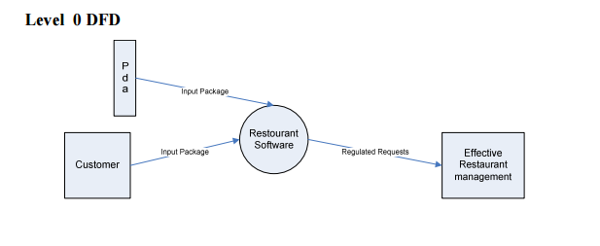

**FIGURE 7**

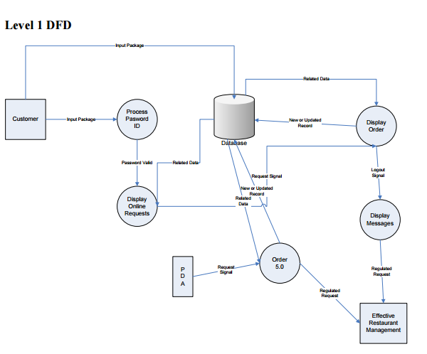

**FIGURE 8**

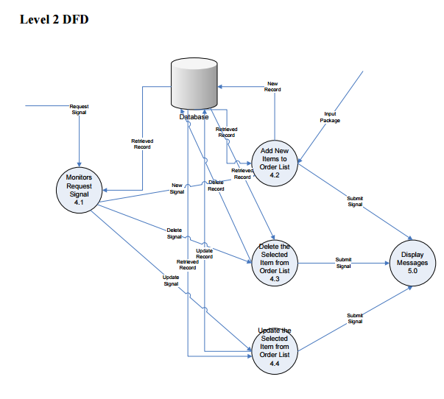

**FIGURE 9**

**CHAPTER 12**

**ENTITY RELATIONSHIP (ER) DIAGRAM**

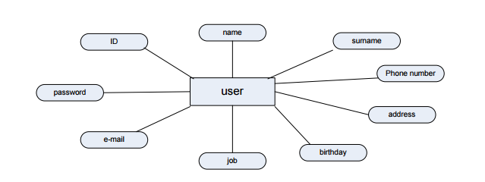

**FIGURE 10**

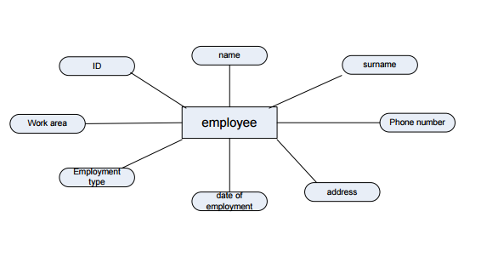

**FIGURE 11**

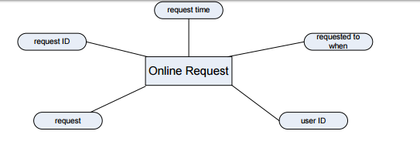

**FIGURE 12**

**CHAPTER 13**

**PROBLEM DEFINATION**

We are going to build a webpage that will have several features such as:

* Stock management
* internet online reservation
* Online ordering via network enabled handheld computer
* Customer management
* Accounting
* Executive information system In addition to those features, we are planning to add
* Statistical data about sales using graphics
* Customer profile (customer name, address, preferences, etc.)

**PROBLEM SOLUTION**

We tried to make the problem more obvious. Because of the fact that the project is in abstract state now, we tried to concretize the project. To achieve that, we tried to think about the similar software examples that are used in real life, like restaurants. One of the reasons to do that was to draw the borders of the problem, how much we can achieve. After drawing the borders of the problem we divided the solution into several parts, which may change during the development of the project:

* Online Reservation: Customers will be able to give their orders via internet. In order to achieve this we are planning to build this part of project in JAVA, as this platform has many facilities in this area.
* Wireless Connection: This type of connection will be used to establish the connection between the hand terminals and main computer. We are planning to use JAVA platform as it has many facilities to generate source code for PDAs. Hand terminals are going to be used for getting the orders from customers and transforming these to the main computer.
* Statistical Analysis: In this part statistics about the products and their sales will be generated. These statistics will be displayed by graphics. This is an extra part for the problem solution in order to ease the sales management.
* Customer Profile: This is another extra part in order to know the customer and his/her preferences better. The information such as customer’s name, favorite food, address, phone number, birthday (system will send automatic greeting via SMS) will be hold in database.
* Database Management: At the moment we are going to use DB2 as database management system. Database will hold the information and data coming from online reservation system, hand terminals, stock management system and customer profiles. Database management is going to be the most frequently used part of the project.

**CHAPTER 14**

**FRONT END SNAPSHOT**

* **HOMEPAGE:**

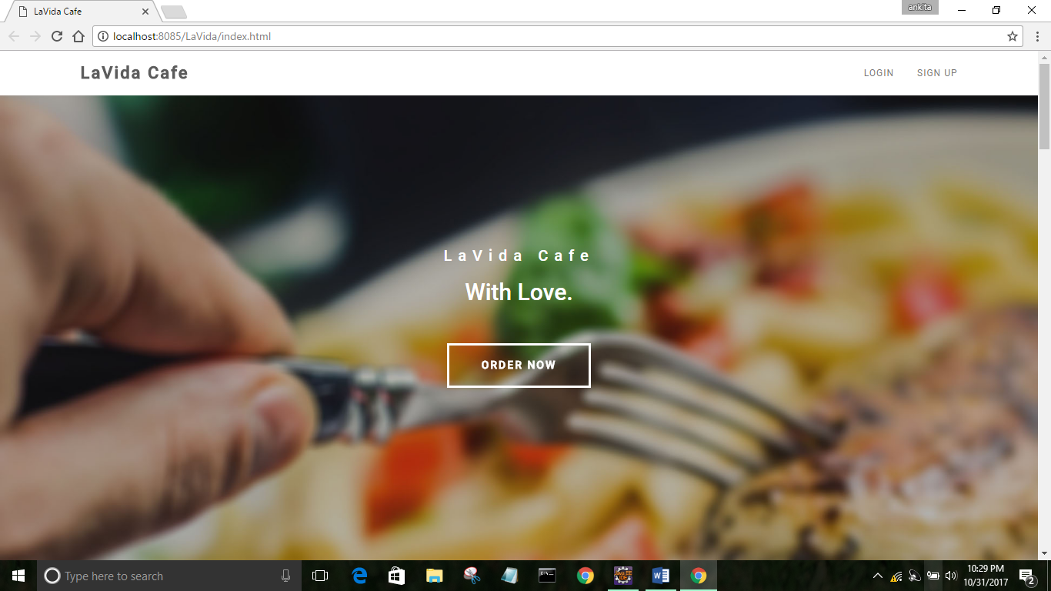

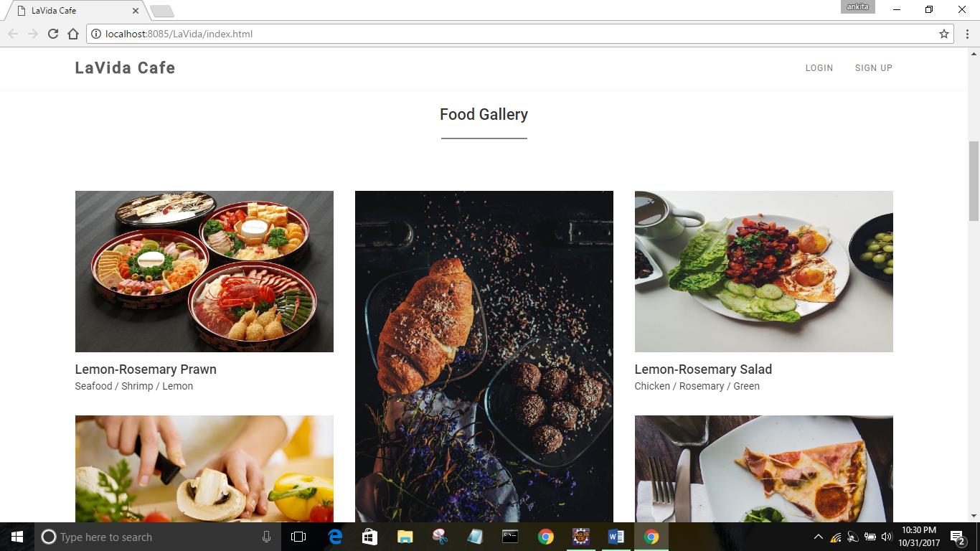

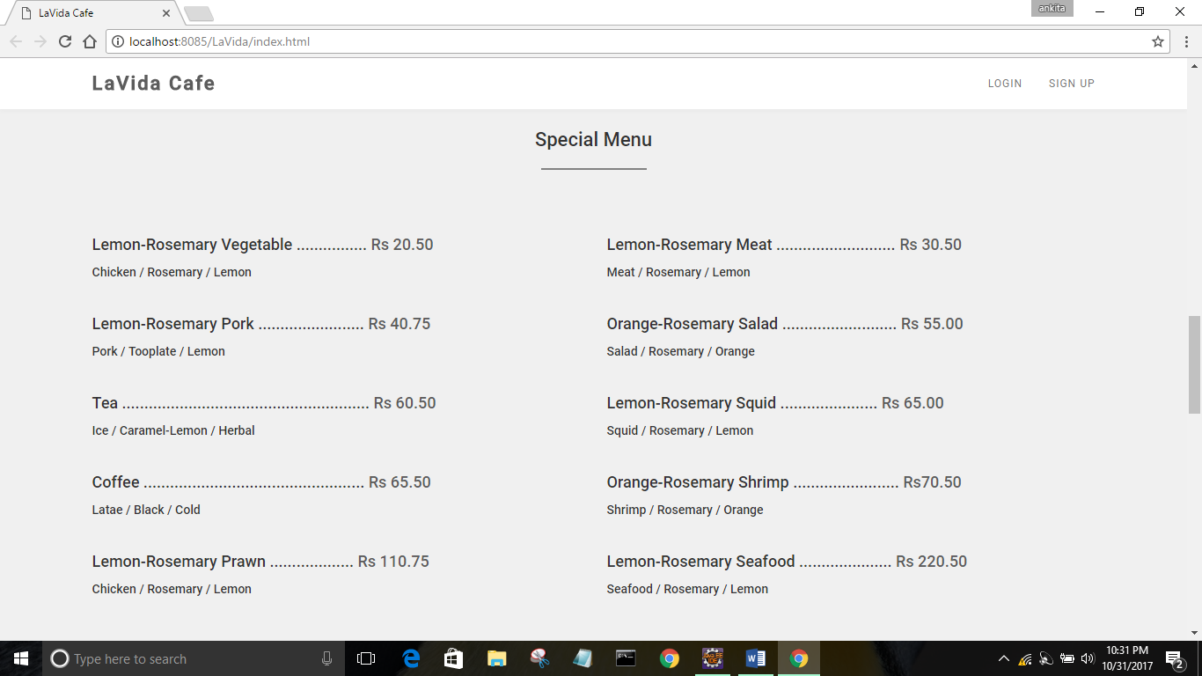

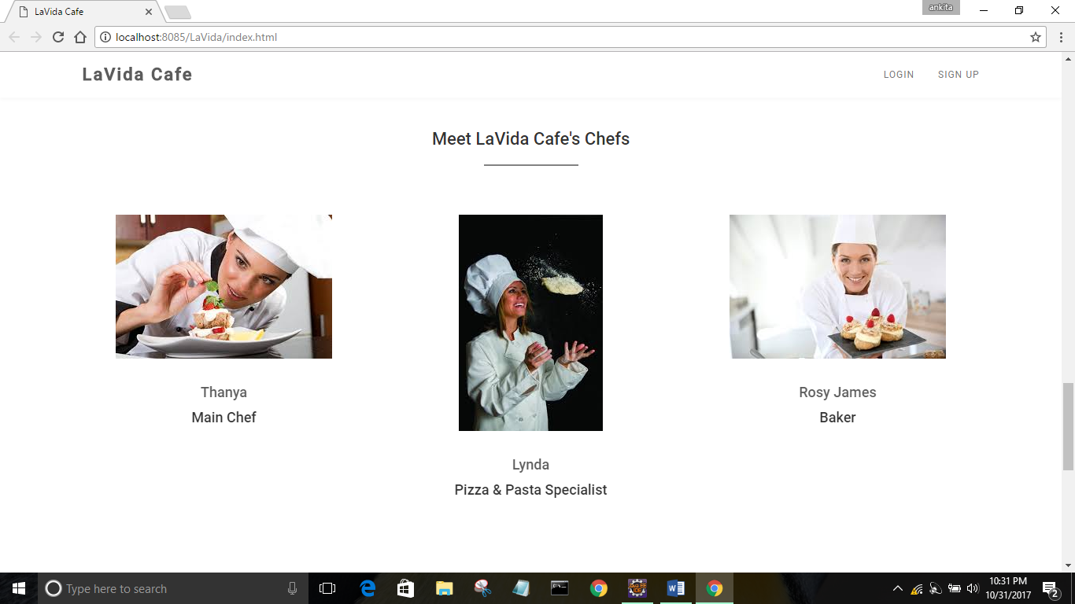

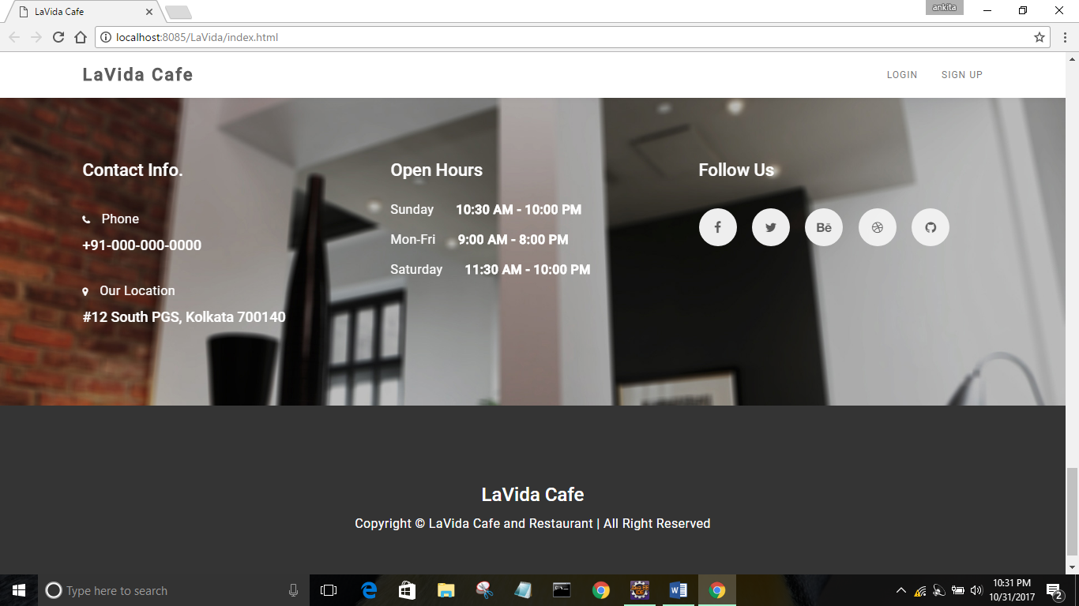

* **LOGIN PAGE:**

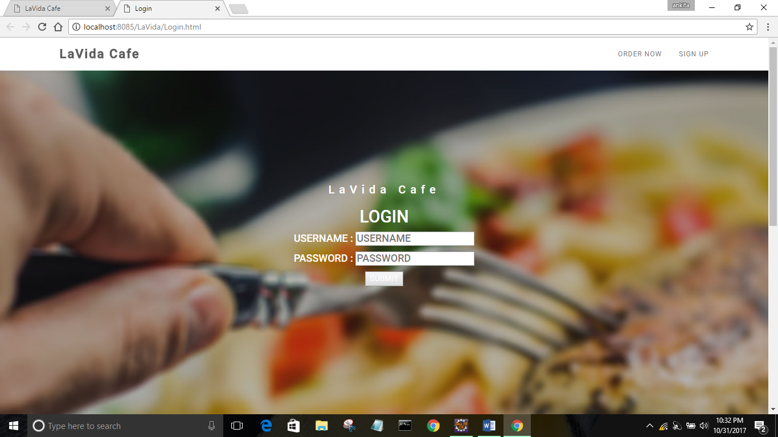

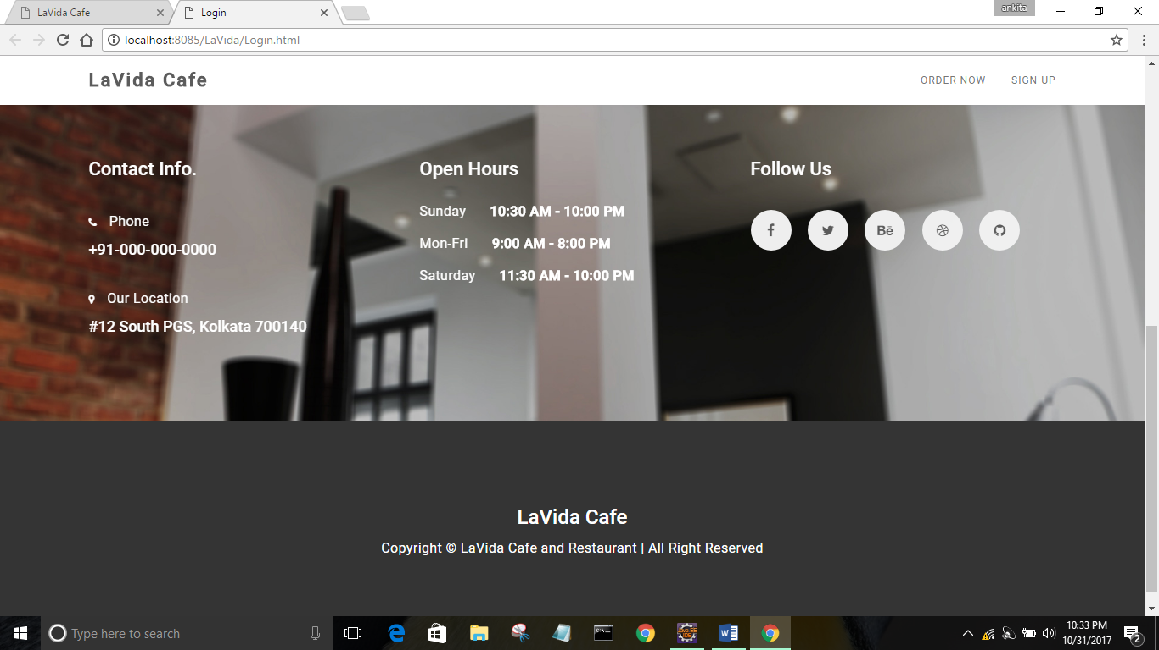

* **REGISTRATION PAGE:**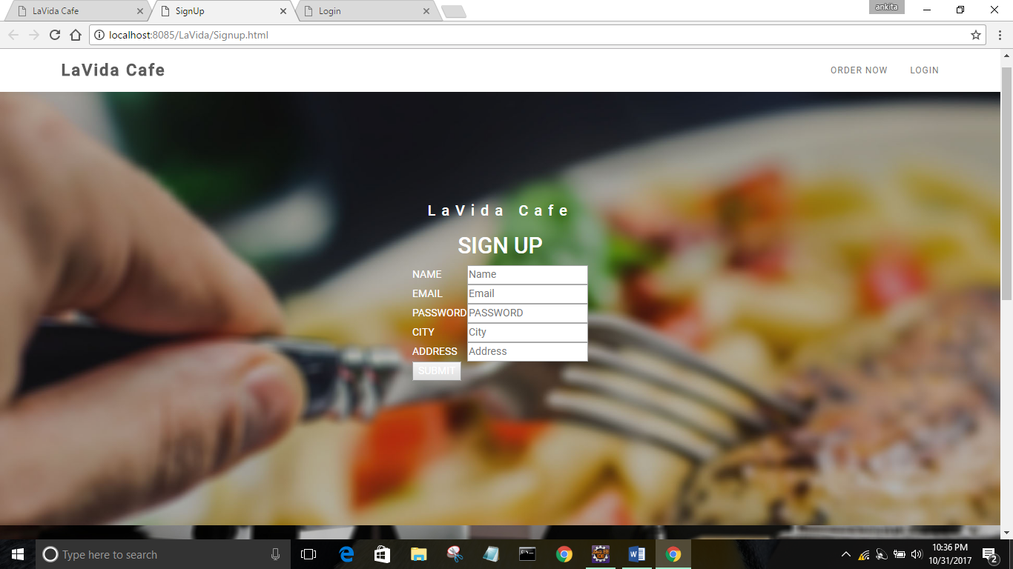

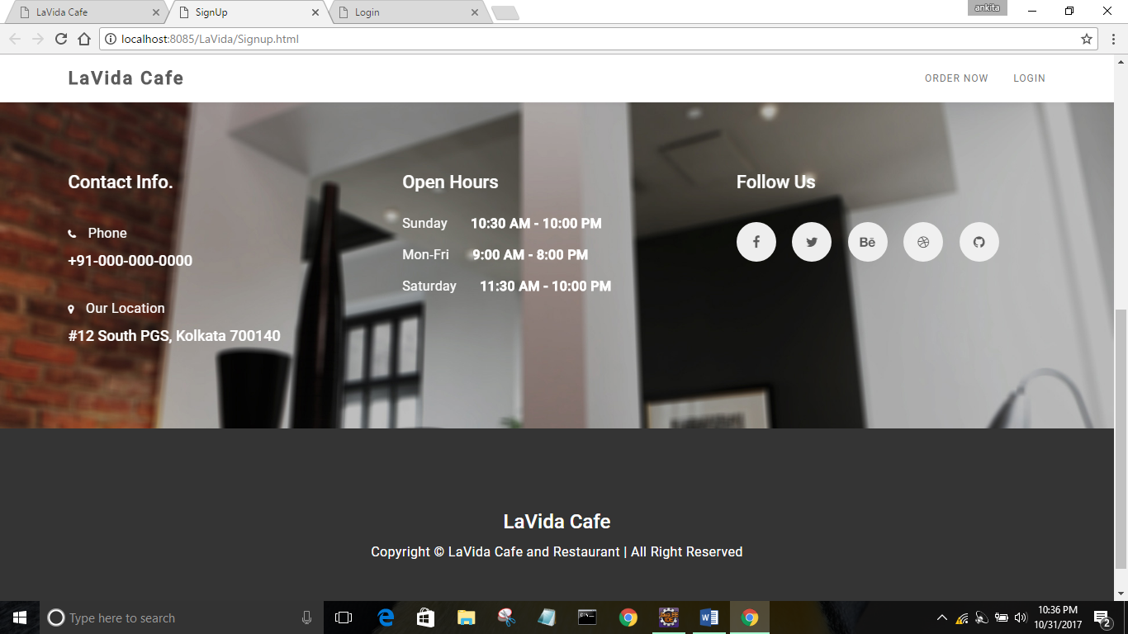

* **ORDER PAGE:**

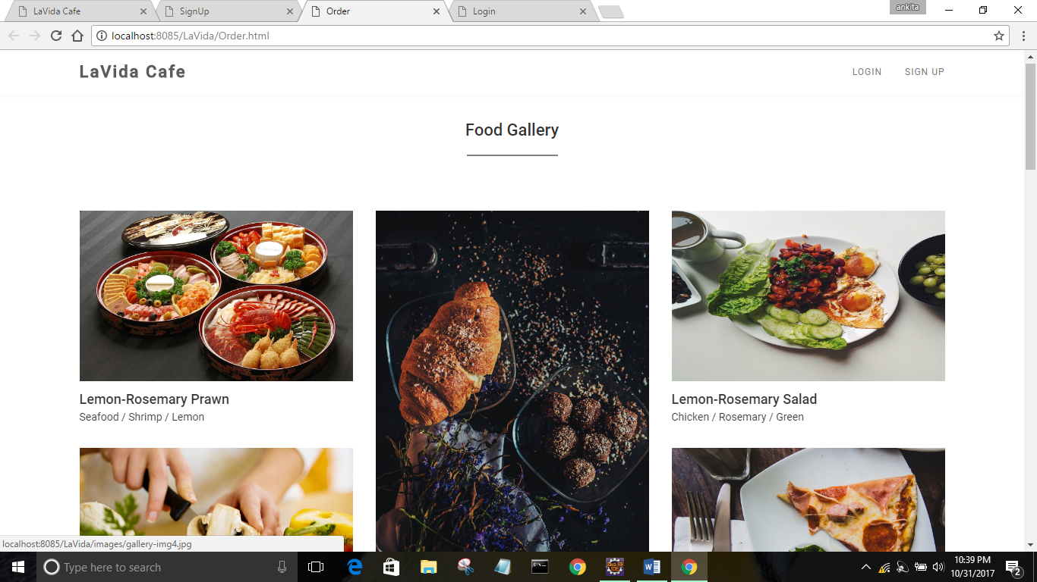

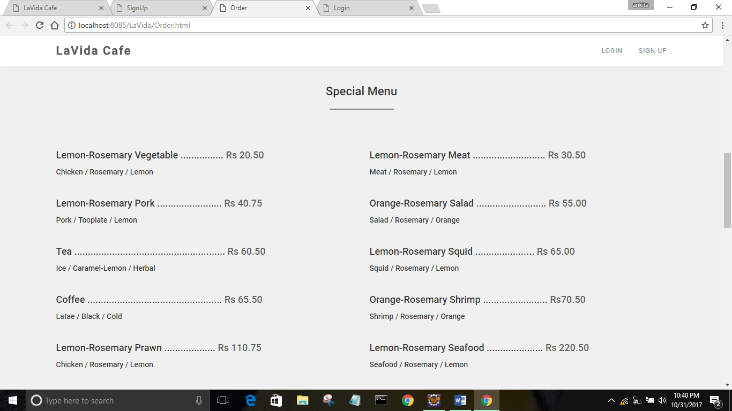

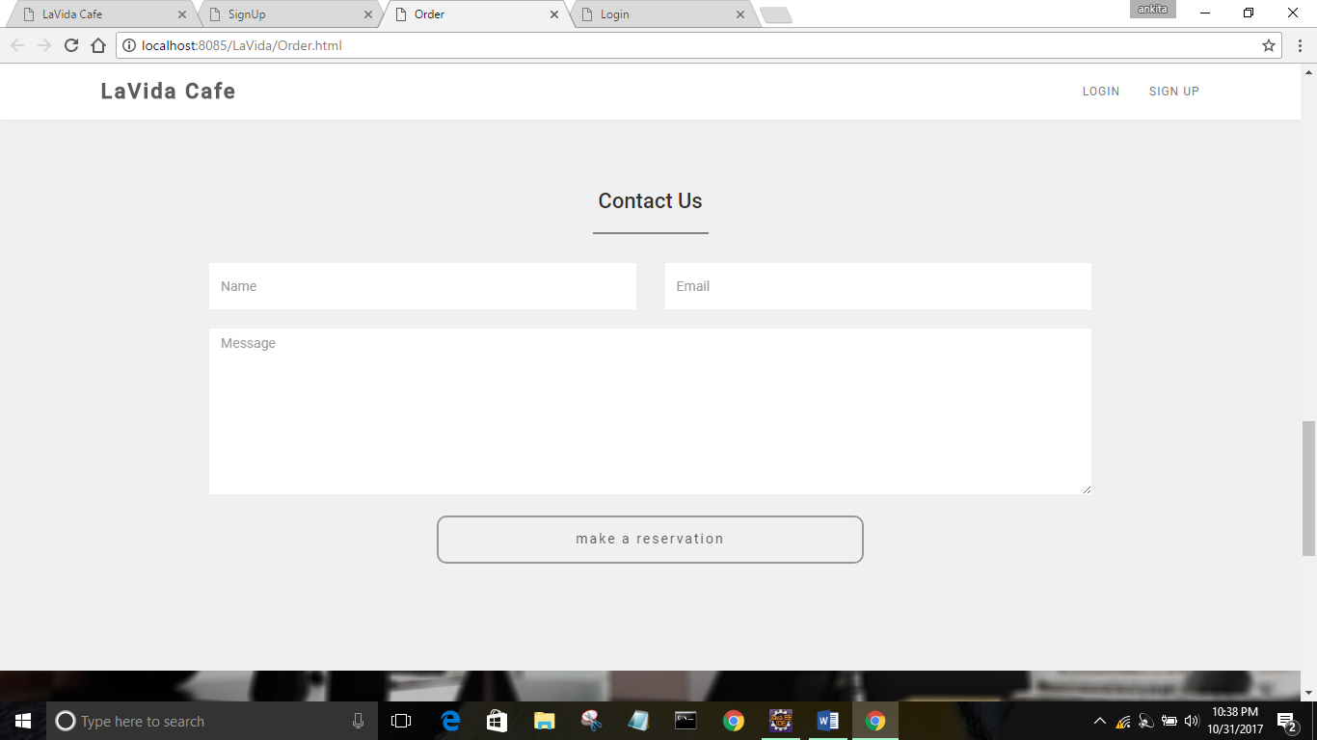

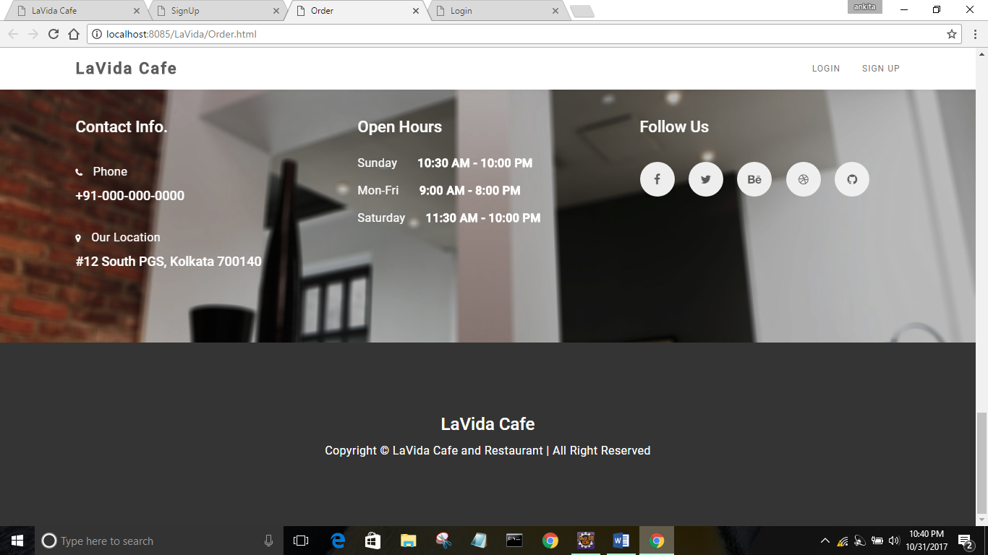

**BACK END SNAPSHOT**

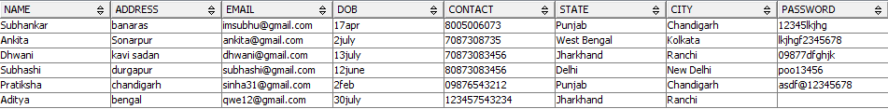

**REFERENCE**

1. <http://getbootstrap.com/>
2. https://www.youtube.com/watch?v=oepmLGQP1m4&list=PLUoqTnNH-2Xz_BUrjcahKWDhPcUjFTOt
3. <http://www.javazoom.net/jzservlets/uploadbean/uploadbean.html>
4. <https://javabrains.io/>
5. [http://www.java2s.com/Tutorial/Java/0360__JSP/JSPDummyShoppingCart.htm 13](http://www.java2s.com/Tutorial/Java/0360__JSP/JSPDummyShoppingCart.htm%2013)
6. <https://docs.oracle.com/cd/E24628_01/server.121/e41484.pdf>
7. https://www.dcc.fc.up.pt/~zp/aulas/0405/es/geral/bibliografia/O'Reilly%20%20JavaServer%20Pages_2nd%20Edition.pdf